This document describes how to setup and test the preliminary version of Midi2Cat an extension to Power SDR that enables midi devices with wheels, knobs, sliders and buttons to be configured.

Up to date only three or four types of DJ Consoles have been supported by Power SDR. Midi2Cat enables using any device support by Windows. Power SDR has only allowed a single device to be used at a time, Midi2Cat addresses this by allowing multiple devices to be connected, configured and used simultaneously.

**Note**

**To enable testing of the original types of midi controllers supported by PowerSdr, this version of PowerSDR has had that support removed. All controllers will have to be mapped using Midi2Cat before they can be used.**

# Getting Started

1) Plug in you DJ Console, or other Device.

2) Open Setup and navigate to the “Cat Control” tab.

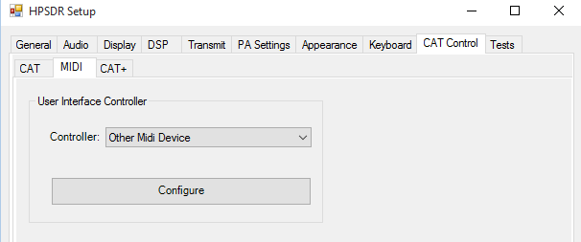

The only option under the “MIDI” tab is Other Midi Device, click Configure to start configuring your console.

3) The Midi2Cat setup page will open.

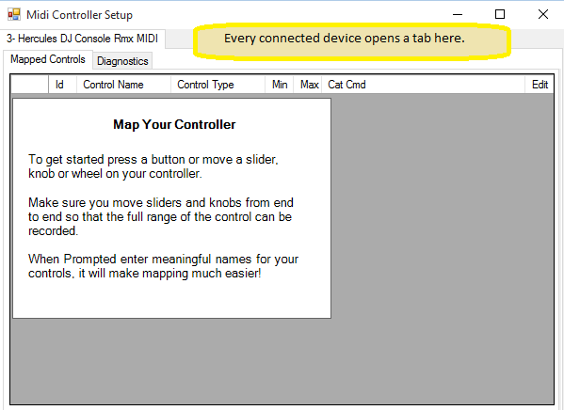

You will see your device name at the top of the page in this case it is “3 – Hercules DJ Console RMX MIDI” if you have plugged in two or more devices you will see a tab for each device. If you have two similar devices they will also appear as two tabs, but the numeric prefix will be different.

i.e. “1-DjConsole” and “2-DJ Console” for each console. Both will need configuring separately.

4) Press a button on your console.

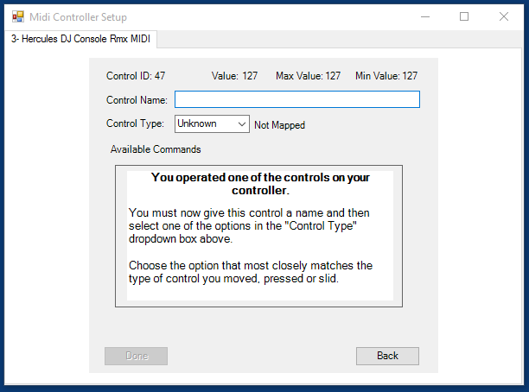

The configure control page will open. Enter a meaningful name for button e.g. “Left Play Button” and then select from the drop down either Button or Toggle. The difference between Button and Toggle is that a Button is a single press action e.g. MOX or USB whereas Toggle is an off/on option e.g. MON on or Off. You can easily switch between the button types to see the available commands that are available, by changing the drop down option.

Setting a control as a Wheel or a Knob, when it is in fact a Button will cause unpredictable results.

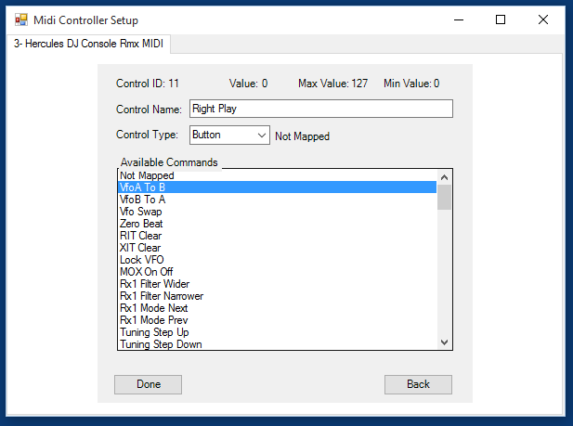

A Midi Control has named “Right Play”, its type has been set to button. When it is pressed it will move the current VFO A setting into VFO B

Pressing Done will save the changes.

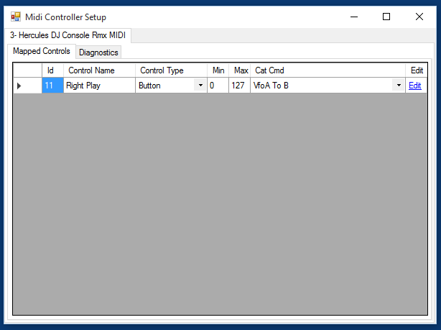

5) Configure the other knobs and buttons and wheels that you wish to use on your controller, by moving each in turn and repeating the above naming process.

When setting up knobs and sliders, move them their full range so that the Min and Max values at the top of the page display all the available values.

6) When you have setup all the controls you wish to use. Close the setup window by pressing the “X” in the top right corner.

Once the setup window has been closed, the new settings will be available to PowerSDR, each control will now perform the option you selected. You can change the settings or add new ones by re-opening setup.

# Commands Tab

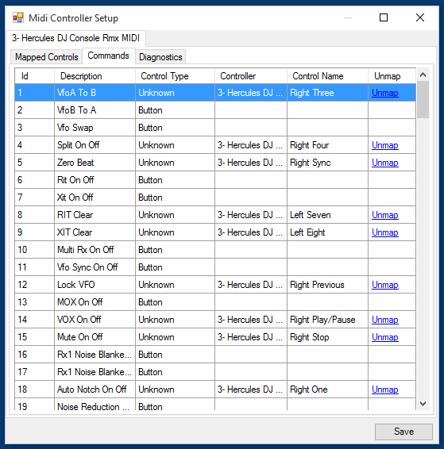

The Commands Tab displays all of the available commands. If you select a row you and then operate a control on your controller the control you operated will be mapped to the command you selected. If you click “Unmap” the any mappings to the selected command will be removed.

# Advanced Options

With the Advanced options you can define MIDI commands to send back to your controller when a midi input event occurs. You need a good understanding of midi short messages and the manual for your controller that defines the messages that are allowed to be sent to the controller.

Warning – Sending invalid or incorrect messages to your controller will cause unpredictable behaviour and might even damage it. You have been warned!

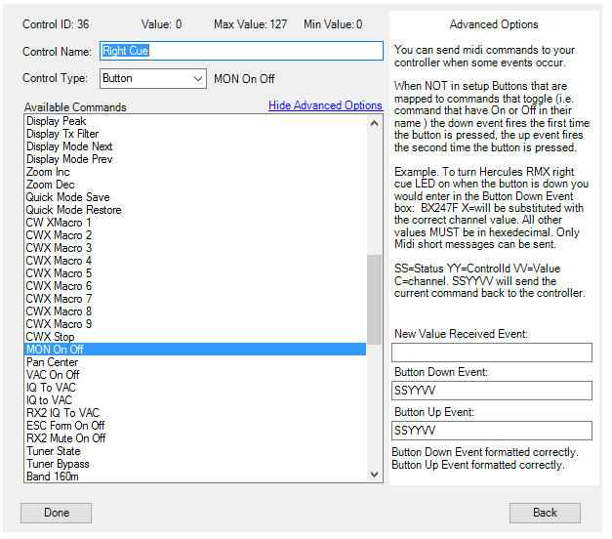

There are three points in time when a message will be sent to you midi controller. 1) When a new message is received. 2) When a button is pressed. 3) When a button is released. Button events are only raised if the “Control Type” is set to “Button”.

If the “Control Type” is “Button” and the command is a toggle command, that it the command name ends with the words “On Off” then down event will be raised on the first push off the button and the up event will be raised when the button is pressed for a second time.

The “New Value Received” event is raised whenever any new data is received from the midi controller.

Continued overleaf…

## Defining Midi Data to send to the controller.

The midi data sent is to the controller is always six hexadecimal characters long.

To make coding of the data easier the following variables can be used when writing your midi command:-

SS = The received midi status byte. This can only be used as the first two characters.

YY = The received Control Id. (data1) . This can only be used as the second two characters.

VV = The received value. (data2) This can only be used as the third two characters.

X = The channel the input was received on.

**Midi Command Example**

I am using the Hercules RMX controllers’ manual to find the MIDI commands for these examples. You will need to use the manual for your Midi Controller. Most manuals can be found on-line using Google.

The manual for the Hercules RMX console states:-

When the Right Cue button is pressed the following hex data will be sent to the PC “B4257F”

When the Right Cue button is released the following hex data will be sent to the PC “B42500”

To light the Right Cue LED send hex “B4257F” to the controller.

To turn off the Right Cue LED send hex “B42500” to the controller.

The hex value “ 7F25B4” received from the Midi Controller comprises of 3 bytes of data.

The “B4” is the midi status byte.

“B” is the midi event type, in this case B=Controller Change.

“4” is the midi channel.

The “25” is the midi Data1 byte on PowerSDR this is the Id of the control that has been operated.

The “7F” is the value sent by the control. Typically for a button 7F is sent when a button is pressed and 00 is sent when the button is released.

**Example - To light the Right Cue LED when the button is pressed, and turn it off when released:**

ButtonDownEvent = B4257F

ButtonUpEvent=B42500

This will work because I know the channel number (4) the data was received on. You will probably not know the channel number so this example is better coded as:

ButtonDownEvent = BX257F

ButtonUpEvent=BX2500

The X will be substituted by PowerSDR with the correct midi channel number.

Since it can be seen from the manual that the data received from the controller when a button is pressed is the same as the data that has to be sent to light the LED we could code the events like this:

ButtonDownEvent = SSYYVV

ButtonUpEvent=SSYYVV

The SS will be substituted with the current midi status byte. The YY will be substituted with the current Control Id, and the VV will be substituted with current value.

**You are free to mix both hex values and the variables.**

For example :- BX1CVV is valid. (set the control (B) on the current channel(X) that has Id of 1C to the received input value.

**Example - To send the received data back to the controller:**

This time we use the New Value Received Event.

NewValueReceivedEvent=SSYYVV

You could of course, use any combination of variables and hex digits.

Unlike the “Button” events The NewValueReceivedEvent is fired when any data is received from the controller so it can be used to update the position of virtual sliders and knobs.

**Caution MUST be taken as it is easily possibly to create a loop. When the slider is moved, a “Slider Moved” message is sent to PowerSDR which is then posted back to the midi controller using NewValueReceivedEvent, the controller moves the slider and then posts another “Slider Moved” message, and so the loop continues…** The only way to break the loop is to restart PowerSDR, immediately go to the settings’ Commands Tab and “UnMap” the looping command.

In a future release the NewValueReceivedEvent may be fired when an associated control on the PC screen is updated, but for now this doesn’t happen.

# Trouble Shooting

If your device does not appear in a tab at the top of the setup page, this is because Windows does not recognise it. You may have to install drivers for the device before it can be used, or it may not be connected correctly.

If the device appears in a tab but pressing buttons and wheels has no effect, open the Diagnostics tab and then move some controls, you should see number scroll down the list on the left. If not check at the top and see if the Midi In Status is “Open”. Also check to see if there are any errors reported. If so please note them down and send them to Andrews M0YGG via Anan Yahoo group.

Diagnostic Tab

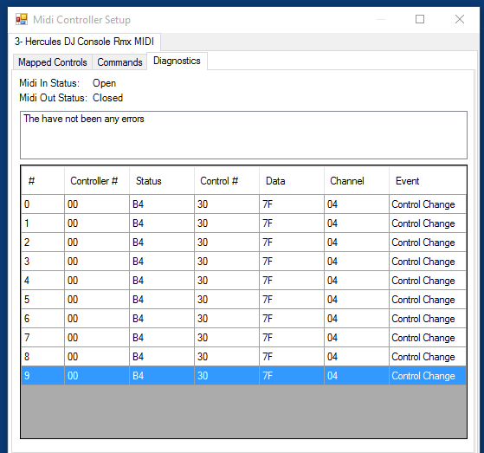

# Saving and Loading Configurations

If you have a controller with only a few controls you can setup and save different configurations for alternative operating modes, for example you might have a button layout for working CW or another when using PSK.

To save your current configuration choose “Save Mapping As” from the Manage Mappings dropdown. You will be prompted for a name for your configuration, enter something meaningful and press save.

Once saved, you can re-map your controls knowing that your previous settings are safe. When you are happy with your new configuration, save that also. You can now switch between the two configurations by picking “Load Mapping” from the Manage Mappings dropdown and selecting the mapping you wish to open.

Should you need to rename or remove configurations use the “Organise Mappings” option in the Manage Mappings dropdown.

# Export and Import - Sharing Your Mappings

You can share your configurations with other users or copy your configuration between PCs using the Export/Import facility.

*Exporting*

Before you can export your configuration it must be saved using the steps detailed above. Once saved choose “Export Mappings” from the Manage Mappings dropdown. You will be prompted for the mappings that you wish to export, tick the checkbox beside the configuration(s) that you wish to export. Pressing “Done” will open a file save window, this is where you decide where you wish to store the exported data and set the name of the export file. The file type will be of type “.m2c” When you press “Save” the file will be created, you can distribute the file as you require.

*Importing*

Should you receive an import.m2c file you can add its contents to your system by choosing “Import Mappings” from the Manage Mappings dropdown. You will be presented with a File Open window, navigate to the import file and press “Open” The file will be opened and you will then be able to choose from the configurations held within the file which configuration you wish to add to your system. If the configuration you require has the same name as an existing configuration stored on your PC the imported configuration will have its import date/time added to its name so as to make it unique. Select the configurations to import by checking the boxes besides the configuration name, then press “Done”. The configurations will be added to your list of saved configurations. Load the new configuration using the “Load Mapping” option.

*Warning*

The location of the database for PowerSDR is well known. It might be tempting to copy and share mappings by copying the actual database. This is ill advised as the data in your database is specific to midi hardware configuration of your PC. It is unlikely to correctly work on another PC. Using the Import/Export facility is the only method to guarantee successfully sharing or migrating mappings.

# Command Reference

The follow pages list all of the available commands that can be associated with a MIDI control.

The three images provide a cross reference and visual clue as to what each command actually controls.

|  |  |
| --- | --- |
| **Commands to be used the Wheel Controls** | |
| 101 | Freq VfoA |
| 102 | Freq VfoB |
| 103 | Filter Bandwidth |
| 104 | RIT |
| 105 | XIT |
| 106 | Zoom Slider |
| 107 | Filter Upper Edge |
| 108 | Filter Lower Edge |
| 109 | Pan |
|  |  |
| **Commands to be used with Knobs or Sliders** | |
| 203 | SHIFT |
| 204 | Volume MainRX |
| 205 | Volume SubRX |
| 206 | Ratio MainRx/SubRx |
| 207 | PreAmp Settings |
| 208 | CW Speed |
| 209 | AF Gain |
| 210 | AGC Threshold |
| 211 | Drive Level |
| 212 | Mic Gain |
| 213 | DX Level |
| 214 | COMP Threshold |
| 215 | Vox Gain |
| 216 | DEXP Threshold |
| 217 | Squelch Threshold |
| 218 | AGC Threshold RX2 |
| 219 | TX AF Monitor |
| 220 | AGC Mode |
| 222 | Volume RX2 |
| 223 | Pan Slider |
| 224 | VAC RX Gain |
| 225 | VAC TX Gain |
| 226 | VAC2 RX Gain |
| 227 | VAC2 TX Gain |
| 228 | Waterfall/Grid Low Limit |
| 229 | Waterfall/Grid High Limit |
| 230 | RX2 Stereo Balance |

|  |  |
| --- | --- |
|  |  |
| **Commands to be used with Button Controls** | |
| 1 | A > B |
| 2 | A < B |
| 3 | A <> B |
| 4 | Split |
| 5 | 0 Beat |
| 6 | RIT |
| 7 | XIT |
| 8 | Clear RIT |
| 9 | Clear XIT |
| 10 | MultiRx |
| 11 | VFO Sync |
| 12 | VFO Lock |
| 13 | MOX |
| 14 | VOX |
| 15 | Mute |
| 16 | NB1 Rx1 |
| 17 | NB2 Rx1 |
| 18 | ANF |
| 19 | NR1 |
| 20 | NR2 |
| 21 | BIN |
| 22 | Wider Filter |
| 23 | Narrower Filter |
| 24 | Next Mode |
| 25 | Prev Mode |
| 26 | Tuning Step Up |
| 27 | Tuning Step Down |
| 28 | Band Up |
| 29 | Band Down |
| 30 | Start |
| 31 | Tuner On/Off |
| 32 | COMP |
| 33 | Phone DX On/Off |
| 34 | DEXP |
| 35 | RX2 On/Off |
| 36 | RX2 Preamp |
| 37 | RX2 NB1 |
| 38 | RX2 NB2 |
| 39 | RX2 Band Up |
| 40 | RX2 Band Down |
| 41 | Enable Rx EQ |
| 42 | Enable Tx EQ |
| 43 | Squelch |
| 44 | Spectral NB |
| 45 | AGC Mode Up |
| 46 | AGC Mode Down |
| 47 | RX2 Spectral NB |
| 48 | AVG |
| 49 | Peak |
| 50 | Show TX Filter |
| 51 | Display Mode Next |
| 52 | Display Mode Prev |
| 53 | Zoom Step Up |
| 54 | Zoom Step Down |
| 55 | Quick Mode Save |
| 56 | Quick Mode Restore |
| 57 | CWX Macro 1 |
| 58 | CWX Macro 2 |
| 59 | CWX Macro 3 |
| 60 | CWX Macro 4 |
| 61 | CWX Macro 5 |
| 62 | CWX Macro 6 |
| 63 | CWX Macro 7 |
| 64 | CWX Macro 8 |
| 65 | CWX Macro 9 |
| 66 | Stop CWX Sending |
| 67 | MON |
| 68 | Pan Center |
| 69 | VAC On/Off |
| 70 | I/Q to VAC1 using RX1 |
| 71 | I/Q to VAC1 using RX2 |
| 72 | VAC2 On/Off |
| 73 | Click Tune On/Off |
| 74 | ESC Form On/Off |
| 75 | Mute RX2 |
| 76 | TUN |
| 77 | Tuner Bypass |
| 78 | 160m |
| 79 | 80m |
| 80 | 60m |
| 81 | 40m |
| 82 | 30m |
| 83 | 20m |
| 84 | 17m |
| 85 | 15m |
| 86 | 12m |
| 87 | 10m |
| 88 | 6m |
| 89 | 2m |
| 90 | 160m RX2 |
| 91 | 80m RX2 |
| 92 | 60m RX2 |
| 93 | 40m RX2 |
| 94 | 30m RX2 |
| 95 | 20m RX2 |
| 96 | 17m RX2 |
| 97 | 15m RX2 |
| 98 | 12m RX2 |
| 99 | 10m RX2 |
| 500 | 6m RX2 |
| 501 | 2m RX2 |
| 502 | Mode SSB |
| 503 | Mode LSB |
| 504 | Mode USB |
| 505 | Mode DSB |
| 506 | Mode CW |
| 507 | Mode CWL |
| 508 | Mode CWU |
| 509 | Mode FM |
| 510 | Mode AM |
| 511 | Mode DIGU |
| 512 | Mode SPEC |
| 513 | Mode DIGL |
| 514 | Mode SAM |
| 515 | Mode DRM |
| 520 | Move VFOA Down 100Khz |
| 521 | Move VFOA Up 100Khz |

# Button Commands - The Red Text Is The Command Id

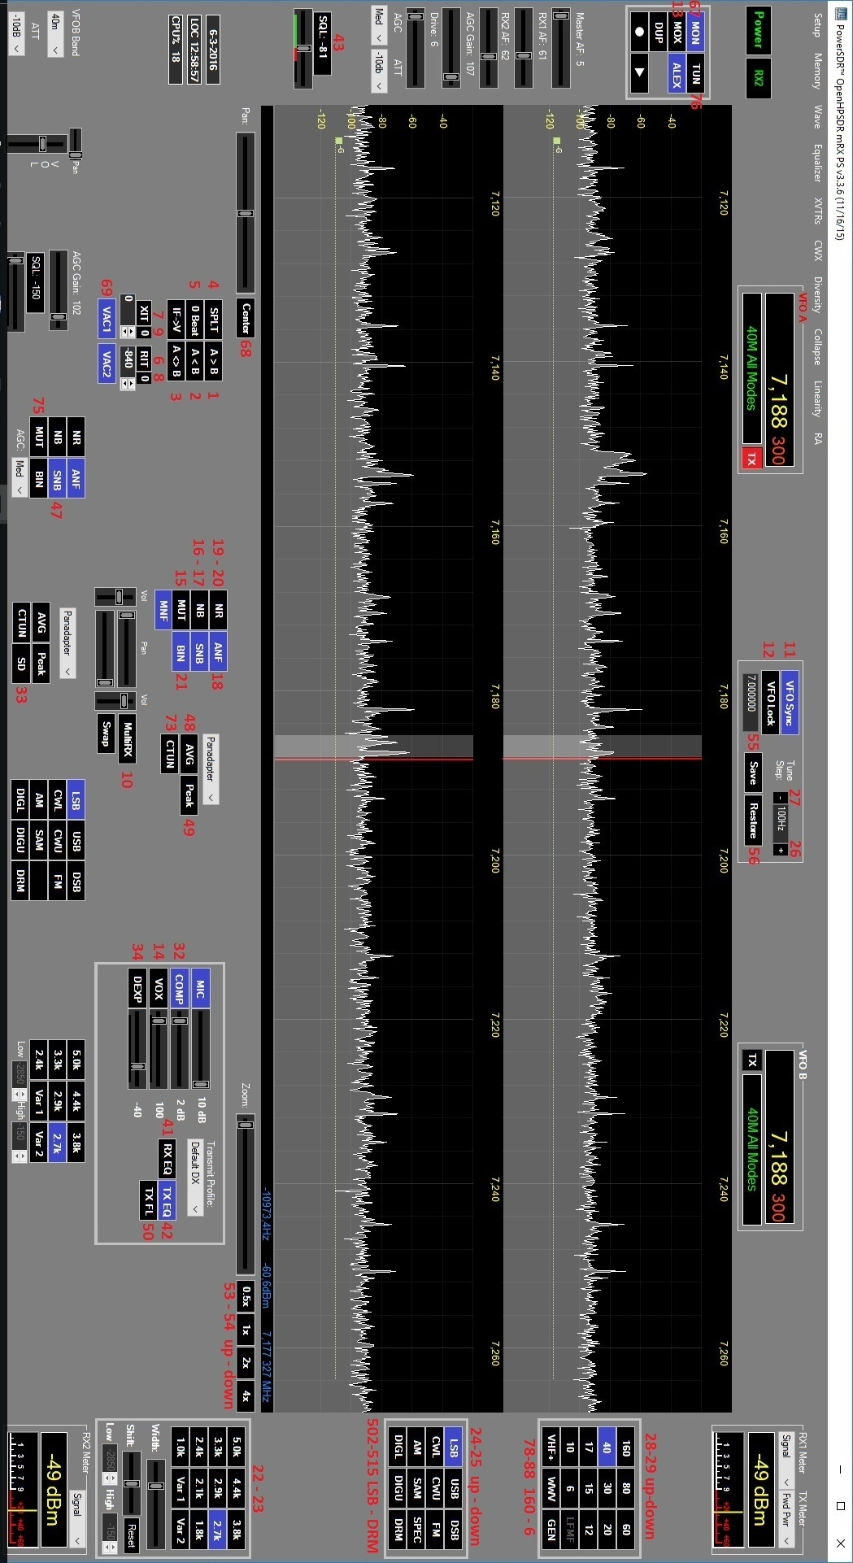

# Knob And Slider Commands - The Red Text Is The Command Id

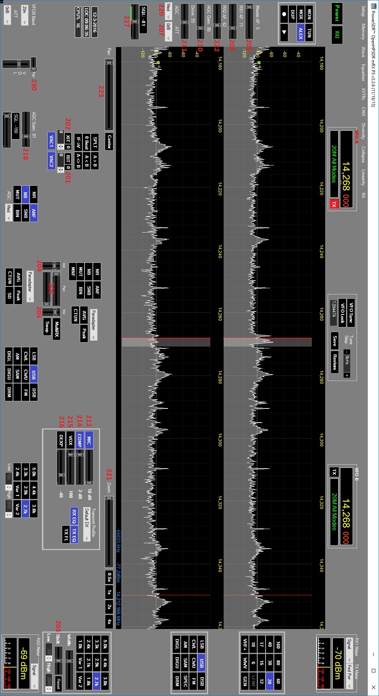

# Wheel Commands - The Red Text Is The Command Id

